TESTING MSM INDIVIDUAL BOARDS

Standard PCB testing for all boards are required; this includes Flying Probe testing and other non-powered types of tests, Solderability test and PCB contamination testing.

- OFP_USM_v1.5

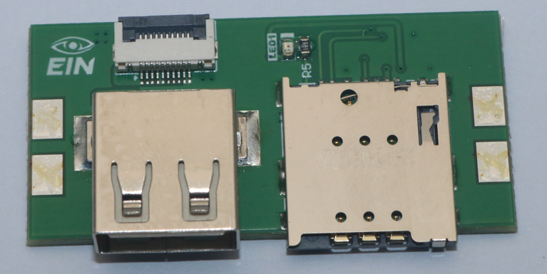

No individual PCB testing required other than standard tests.

- OFP_VIM_v1.5

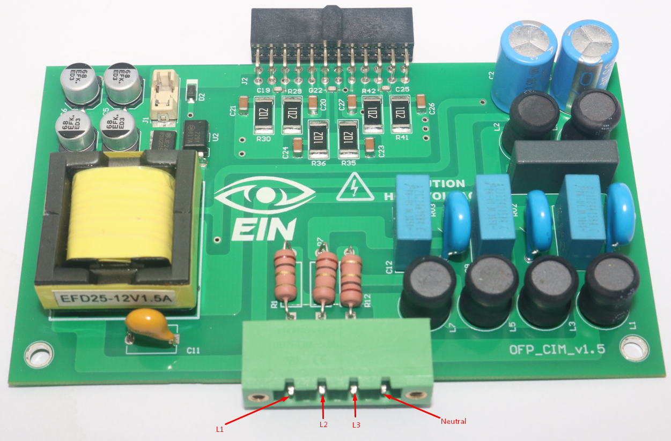

After passing the standard PCB testing. The following will be carried out next:

- Apply a standard 220V AC voltage source at L1 and Neutral. The voltage source should be well protected.
- Measure the voltage across the C6 capacitor and report voltages. The nominal voltage would be in 11.5V to 13.5V at 60% load. The safe voltage range is 9V to 16V at full load. The maximum current of this supply is 1.5A at 12V.
- If the voltages are within safe voltage range limits then apply a resistive load of 75% and measure the voltage across the C6 capacitor.
- Vary the input voltage between 100VAC and 250VAC under load conditions. The output voltage must remain within a safe and stable operating range throughout.
- Measure temperature increase of the T1 transformer and components having designators Q1, U1, D1, BR1, BR2. Continue this test over a period of 15-30 minutes.
- Measure temperature over R25-R42 resistors and R1, R7 R12 at load.
- Apply a standard 220V AC voltage source at L2 and Neutral and repeat and report the above steps.
- Apply a standard 220V AC voltage source at L3 and Neutral and repeat and report the above steps.
- Now apply a standard 220V 3-phase AC voltage source at L1, L2, L3 and Neutral and repeat and report the above steps.

- OFP_CIM_v1.5

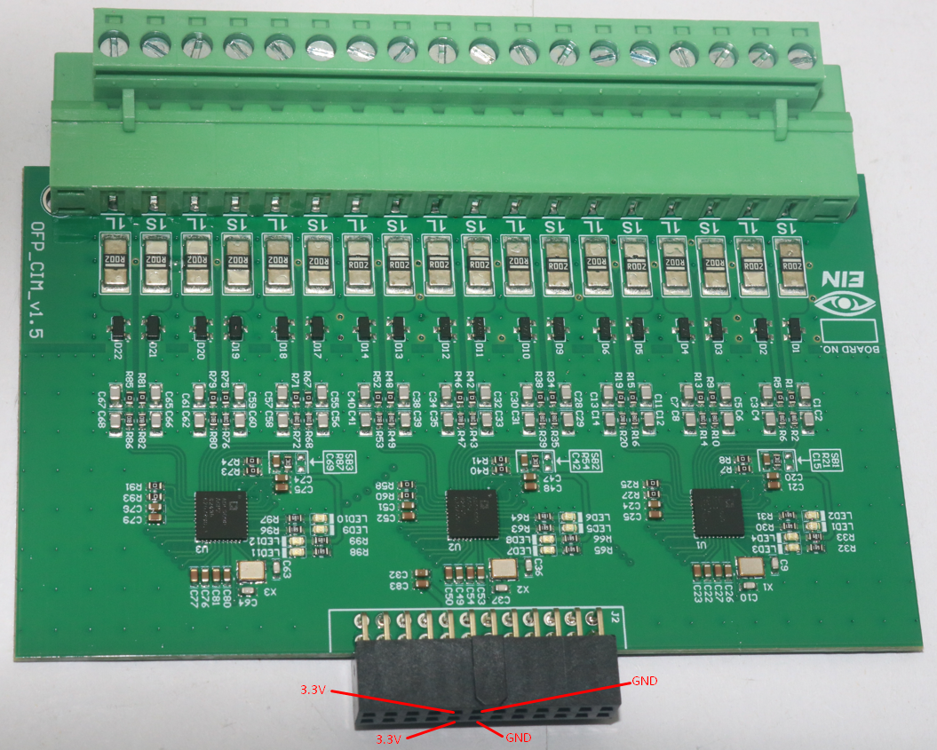

Power shortage test required. If passed, a regulated 3.3V source are the terminals in the given image and measure U1, U2, U3 temperatures if they are heating or not due to some other unknown issue. The 3.3V pins are 9 and 10. The GND pins are 11 and 12.

- OFP_SCM_v1.5
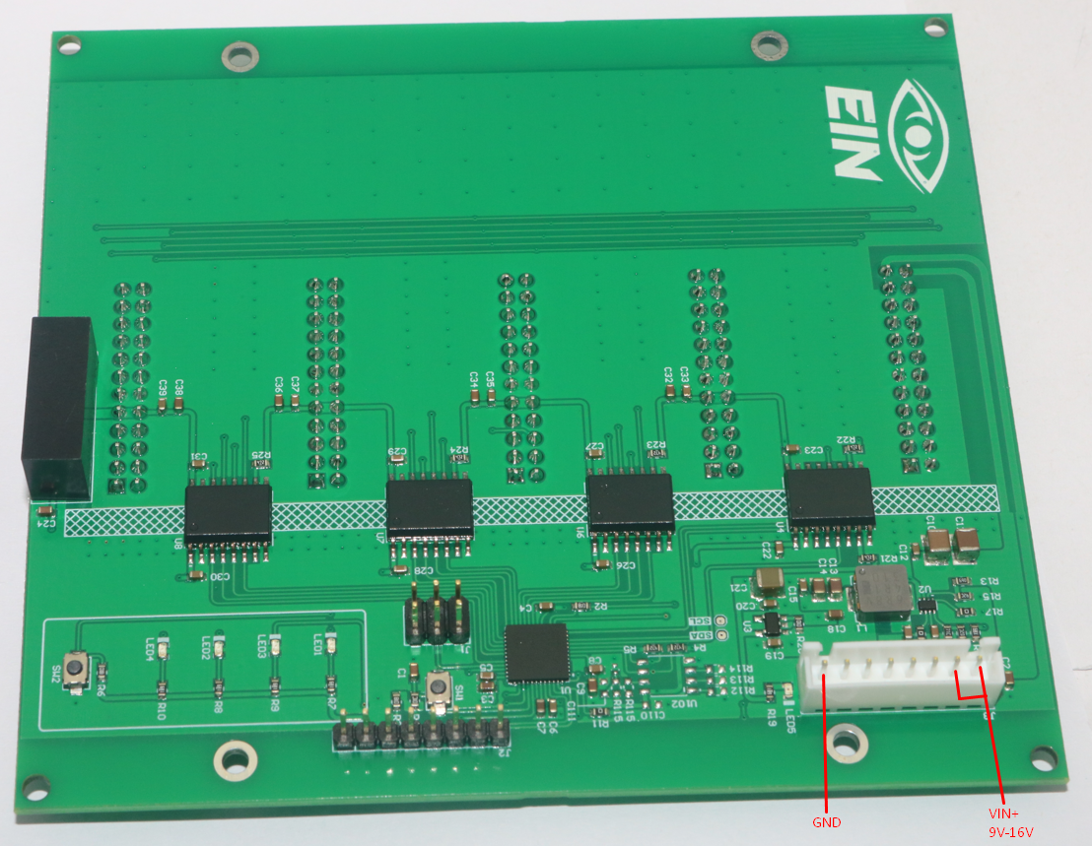

- Power shortage test required. If passed, a 12V DC source is applied at VIN+ and GND.
- Measure voltage across C13 or C14. There should be a stable 5V.
- Measure voltage across C21. It should be stable 3.3V.
- Measure voltage across C25. It should be stable 3.3V.

- OFP_MCM_v1.5
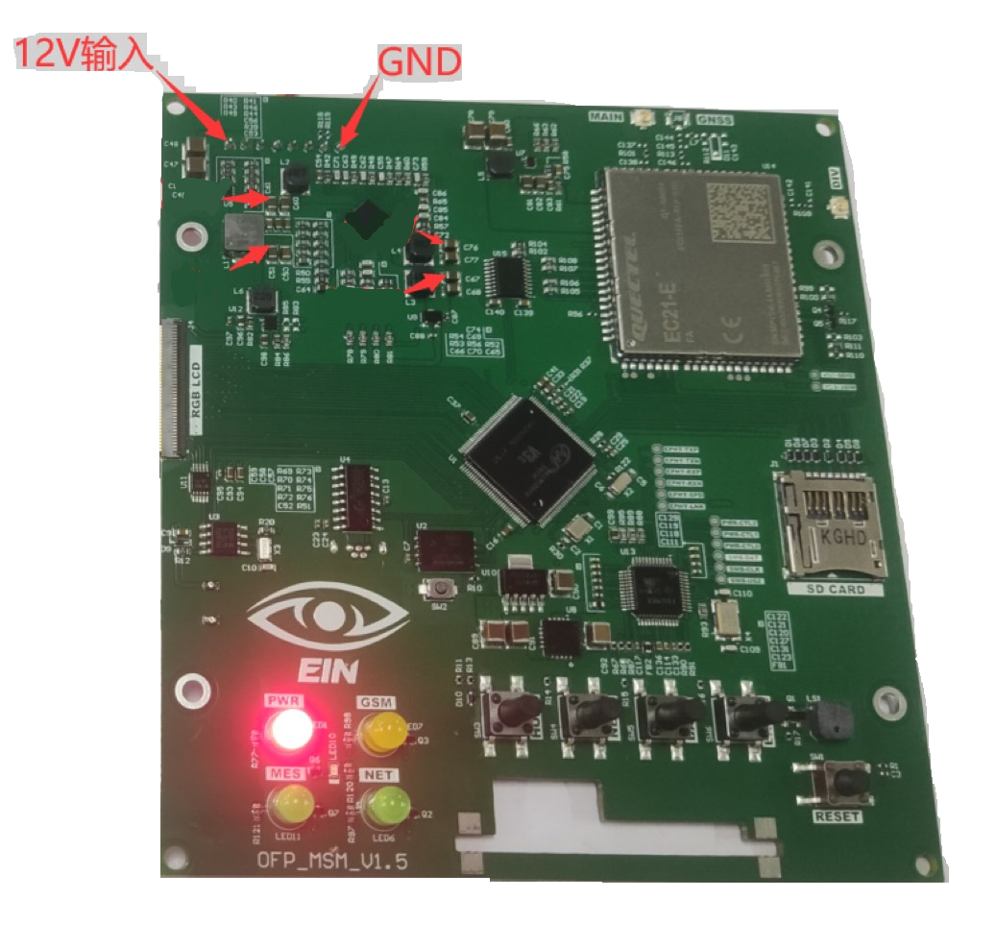

- Power shortage test required. If passed, a 12V DC source is applied at VIN+ and GND.
- Measure voltage across C61. It should have a stable 1.2V.
- Measure voltage across C68. It should have a stable 3.3V.
- Measure voltage across C77. It should have a stable 1.8V.
- Measure voltage across C88. It should have a stable 3.0V.
- Measure voltage across C50. It should have a stable 5.0V.
- Measure voltage across C82. It should have a stable 3.8V.
- Measure voltage across C90. It should have a stable 3.3V.
- Measure voltage across C92. It should have a stable 1.1V.

